LINKS SITE CADA PLANTA
🥬 Alface Crespa

https://marciaalves4-sketch.github.io/HORTA-ESCOLAR/plantas/alface-crespa.html

🥬 Alface Deva

https://marciaalves4-sketch.github.io/HORTA-ESCOLAR/plantas/alface-deva.html

🥬 Alface Mimosa


https://marciaalves4-sketch.github.io/HORTA-ESCOLAR/plantas/alface-mimosa.html

🥦 Brócolis Calabresa

https://marciaalves4-sketch.github.io/HORTA-ESCOLAR/plantas/brocolis-calabresa.html
🧅 Cebola Baia

https://marciaalves4-sketch.github.io/HORTA-ESCOLAR/plantas/cebola-baia.html
🌱 Cebolinha

https://marciaalves4-sketch.github.io/HORTA-ESCOLAR/plantas/cebolinha.html
🥕 Cenoura Baia

https://marciaalves4-sketch.github.io/HORTA-ESCOLAR/plantas/cenoura-baia.html

🥕 Cenoura Nantes


https://marciaalves4-sketch.github.io/HORTA-ESCOLAR/plantas/cenoura-nantes.html

🌿 Coentro Português

https://marciaalves4-sketch.github.io/HORTA-ESCOLAR/plantas/coentro-portugues.html
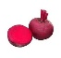 Beterraba

https://marciaalves4-sketch.github.io/HORTA-ESCOLAR/plantas/beterraba.html
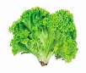Alface Great Lakes

https://marciaalves4-sketch.github.io/HORTA-ESCOLAR/plantas/alface-great-lakes.html

Rabanete Crimson

https://marciaalves4-sketch.github.io/HORTA-ESCOLAR/plantas/rabanete-crimson.html
Acelga

https://marciaalves4-sketch.github.io/HORTA-ESCOLAR/plantas/acelga.html
• Rúcula

https://marciaalves4-sketch.github.io/HORTA-ESCOLAR/plantas/rucula.html

• Repolho Krishana

https://marciaalves4-sketch.github.io/HORTA-ESCOLAR/plantas/repolho-krishana.html
• Manjericão

https://marciaalves4-sketch.github.io/HORTA-ESCOLAR/plantas/manjericao.html
• Pimentão Casca Dura

https://marciaalves4-sketch.github.io/HORTA-ESCOLAR/plantas/pimentao-casca-dura.html

🥬 Couve Chinesa

https://marciaalves4-sketch.github.io/HORTA-ESCOLAR/plantas/couve-chinesa.html

🥬 Couve Manteiga

https://marciaalves4-sketch.github.io/HORTA-ESCOLAR/plantas/couve-manteiga.html

🌿 Manjericão

https://marciaalves4-sketch.github.io/HORTA-ESCOLAR/plantas/manjericao.html

❤️ Rabanete Carmesim

https://marciaalves4-sketch.github.io/HORTA-ESCOLAR/plantas/rabanete-crimson.html

🌱 Rúcula Folha Larga

https://marciaalves4-sketch.github.io/HORTA-ESCOLAR/plantas/rucula-folha-larga.html

🍅 Tomate Cereja

https://marciaalves4-sketch.github.io/HORTA-ESCOLAR/plantas/tomate-cereja.html

🍅 Tomate
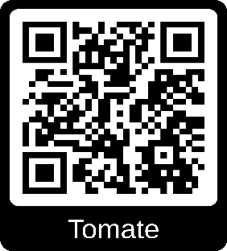

https://marciaalves4-sketch.github.io/HORTA-ESCOLAR/plantas/tomate.html

